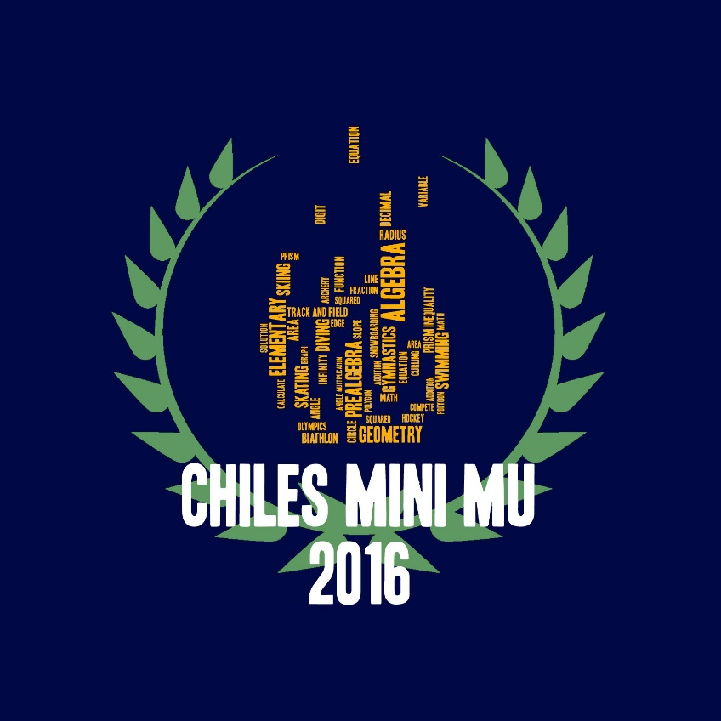

*Chiles High School*

*Tallahassee, FL*

*10 December 2016*

**ALGEBRA I**

**SESSION 1**

**ARCHERY and SHOOTING**